 | CENTRAL BOARD OF SECONDARY EDUCATION


JAWAHAR NAVODAYA VIDYALAYA
TARIKHET ALMORA UTTARAKHAND 263663
COMPUTER SCIENCE (083)
PROJECT FILE
On
BANK ACCOUNT MANAGEMENT SYSTEM USING BINARY FILE
SESSION: 2026-27
SUBMITTED BY :
S. No | Name | CBSE Roll
1.
2.
3.
4.

CLASS : XII
SECTION : SCIENCE

INTERNAL EXAMINER  (PANKAJ BHILINGWAL) |  | EXTERNAL EXAMINER |  | PRINCIPAL  (PANKAJ KUMAR SRIVASTAVA)

ACKNOWLEDGEMENT
I wish to express my deep sense of gratitude and indebtedness to our learned teacher Pankaj Bhilingwal, PGT Computer Science, J.N.V Tarikhet Almora for his invaluable help, advice and guidance in the preparation of this project file.
I am also greatly indebted to our principal Pankaj Kumar Srivastava and school authorities for providing me with the facilities and requisite laboratory conditions for making this project file.
I also extend my thanks to a number of teachers, my classmates and friends who helped me to complete this project file successfully.

Signature of Student

CERTIFICATE
This is to certify that,
S. No | Name | CBSE Roll

Student of Class XII, J.N.V Tarikhet Almora has completed the PROJECT FILE titled “Bank Account Management System Using Binary File” during the academic year 2026-27 towards partial fulfilment of credit for the Computer Science Project evaluation of CBSE and submitted satisfactory report, as compiled in the following pages, under my supervision.
Internal Examiner | External Examiner
Signature | Signature

PREFACE
In the field of Computer Science, the term PROJECT refers to a computerization work that is completely performed by using a computer. Today almost every field is computerized, and the different tasks of every field are done using computers and appropriate computer programs. Such programs and software are developed in the form of Projects.
Learning Python in schools is a part of our syllabus, and according to the syllabus worked out by the CBSE, to which my school is affiliated, I enjoyed doing project work for the session 2026-27. I learned a lot, especially learning by doing was a great experience. The report is a summary of what I observed and learnt in school. My humble thanks go to all those concerned with my project.
I also feel that it is the right time to thank my teacher, who guided me during my project, and my parents, friends and project partners for the constant assistance and cooperation extended by them from time to time.

INDEX
S. No | Topic | Page No
1 | About Project | 6
2 | Syllabus Concepts Used | 8
3 | Flow Chart | 9
4 | Project Code | 10
5 | Output | 14
6 | Technological Requirements: Hardware & Software | 20
7 | References | 20

About Project

Bank Account Management System Using Binary File
The Bank Account Management System is a menu-driven Python program that works like a small bank. It can open new accounts, deposit and withdraw money, transfer money between accounts and show the balance of any account.
Account records are stored as dictionaries in a binary file (accounts.dat) using the pickle module. The program uses exception handling so that wrong inputs, missing accounts or low balance never crash the program. It also has an UNDO feature that reverses the last transaction using a stack.

Project Overview
Objective:
The objective of this project is to practise binary file handling and exception handling together in a real-life application, and to show how a stack can be used to provide an Undo facility, as seen in many software applications.
Key Features:
- Create Account: Opens a new Saving or Current account with an automatically generated account number (1001, 1002, ...). Minimum opening amount is Rs. 500.
- Deposit Money: Adds money to an account and saves the updated balance in the file.
- Withdraw Money: Withdraws money only if a minimum balance of Rs. 500 remains.
- Transfer Money: Moves money from one account to another account.
- Balance Enquiry: Shows the details and balance of one account.
- Display All Accounts: Shows all accounts in a neat table.
- Undo Last Transaction: Reverses the latest deposit, withdrawal or transfer using a stack (LIFO).
- Error Handling: Handles wrong input, account not found and insufficient balance with clear messages.

Technology Stack
Programming Language: Python 3
Modules Used: pickle
Each account is a dictionary {acc_no, name, type, balance}. New records are added with pickle.dump() in append mode ('ab'). To read all records, pickle.load() is called in a loop until EOFError is raised. To update a record, all records are read into a list, changed, and written back with mode 'wb'. A list named transactions works as a stack for the Undo feature.

Files in this Project
File | Purpose
bank.py | Main program
accounts.dat | Binary file storing the account records (created automatically)
flowchart.py | Python program that draws the flowchart using graphviz
flowchart.png | Flowchart image
img/ | Screenshots of the output

How to Run the Program
- Make sure Python 3 is installed on the computer.
- Copy the project folder to the computer.
- Open bank.py in IDLE and press F5 (or run: python bank.py).
- Delete accounts.dat if you want to start with no accounts.

Syllabus Concepts Used
This project covers the following topics of the CBSE Class XII Computer Science (083) syllabus:
Concept | Where it is used in the project
Binary file handling | pickle.dump() and pickle.load(); file modes 'rb', 'wb' and 'ab'
Reading till end of file | while True loop with pickle.load() stopped by EOFError
Exception handling | try, except ValueError, except FileNotFoundError, except EOFError, finally
Raising exceptions | raise ValueError(...) for invalid account and insufficient balance
Stack | List transactions: append() to PUSH, pop() to POP in undo_last()
Dictionaries | Each account record is a dictionary
User-defined functions | Separate function for each operation, helper functions get_number() and get_account()
Global variables | transactions, FILE_NAME and MIN_BALANCE are used by many functions
String formatting | % formatting to print the accounts table

Why exception handling?
An exception is an error that occurs while the program is running, for example entering 'abc' where a number is expected (ValueError) or opening a file that does not exist (FileNotFoundError). Without handling, the program stops suddenly.
With try-except blocks the program catches the error and shows a friendly message instead. The finally block always runs, so it is used to close the file. The raise statement lets us create our own error, e.g. when the balance is not enough.

Flow Chart

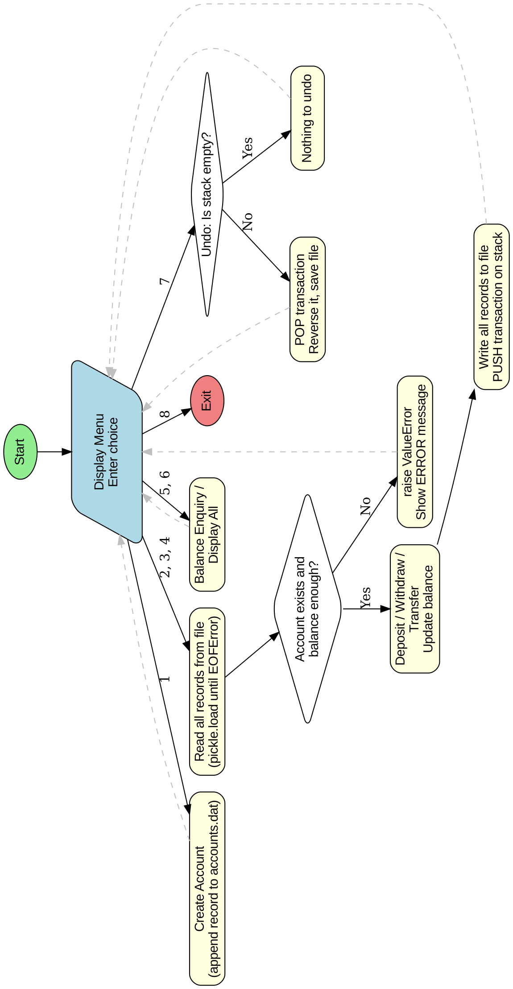

Project Code
# Bank Account Management System
# Uses: Binary file (pickle), Exception handling, Stack (for UNDO)
import pickle
FILE_NAME = "accounts.dat"
MIN_BALANCE = 500
# Stack to remember transactions of this session (for UNDO)
# Each item: [type, account_no, amount, to_account]
transactions = []
# ---------------- File handling ----------------
def read_all_accounts():
# Read every record (dictionary) from the binary file
accounts = []
f = None
try:
f = open(FILE_NAME, "rb")
while True:
acc = pickle.load(f)
accounts.append(acc)
except FileNotFoundError:
pass # first run: file does not exist yet
except EOFError:
pass # end of file reached
finally:
if f is not None:
f.close()
return accounts
def write_all_accounts(accounts):
f = open(FILE_NAME, "wb")
for acc in accounts:
pickle.dump(acc, f)
f.close()
def find_account(accounts, acc_no):
for acc in accounts:
if acc["acc_no"] == acc_no:
return acc
return None
# ---------------- Input helpers ----------------
def get_number(message):
# Keep asking until a valid whole number is entered
while True:
try:
num = int(input(message))
if num <= 0:
print("Please enter a number greater than 0.")
else:
return num
except ValueError:
print("Invalid input! Please enter digits only.")
def get_account(accounts, message):
acc_no = get_number(message)
acc = find_account(accounts, acc_no)
if acc is None:
raise ValueError("Account " + str(acc_no) + " does not exist.")
return acc
# ---------------- Menu options ----------------
def create_account():
accounts = read_all_accounts()
if len(accounts) == 0:
acc_no = 1001
else:
acc_no = accounts[-1]["acc_no"] + 1
name = input("Enter Account Holder Name: ")
acc_type = input("Enter Account Type (S-Saving / C-Current): ").upper()
if acc_type == "C":
acc_type = "Current"
else:
acc_type = "Saving"
amount = get_number("Enter Opening Amount (minimum Rs. 500): ")
if amount < MIN_BALANCE:
raise ValueError("Opening amount must be at least Rs. 500.")
acc = {"acc_no": acc_no, "name": name, "type": acc_type, "balance": amount}
f = open(FILE_NAME, "ab") # append a new record
pickle.dump(acc, f)
f.close()
print("Account created successfully! Your Account Number is", acc_no)
def deposit():
accounts = read_all_accounts()
acc = get_account(accounts, "Enter Account Number: ")
amount = get_number("Enter amount to deposit: ")
acc["balance"] = acc["balance"] + amount
write_all_accounts(accounts)
transactions.append(["DEPOSIT", acc["acc_no"], amount, 0])
print("Rs.", amount, "deposited. New Balance: Rs.", acc["balance"])
def withdraw():
accounts = read_all_accounts()
acc = get_account(accounts, "Enter Account Number: ")
amount = get_number("Enter amount to withdraw: ")
if acc["balance"] - amount < MIN_BALANCE:
raise ValueError("Insufficient balance! Minimum balance Rs. 500 must remain.")
acc["balance"] = acc["balance"] - amount
write_all_accounts(accounts)
transactions.append(["WITHDRAW", acc["acc_no"], amount, 0])
print("Rs.", amount, "withdrawn. New Balance: Rs.", acc["balance"])
def transfer():
accounts = read_all_accounts()
sender = get_account(accounts, "Enter YOUR Account Number: ")
receiver = get_account(accounts, "Enter RECEIVER Account Number: ")
if sender["acc_no"] == receiver["acc_no"]:
raise ValueError("Sender and receiver cannot be the same.")
amount = get_number("Enter amount to transfer: ")
if sender["balance"] - amount < MIN_BALANCE:
raise ValueError("Insufficient balance! Minimum balance Rs. 500 must remain.")
sender["balance"] = sender["balance"] - amount
receiver["balance"] = receiver["balance"] + amount
write_all_accounts(accounts)
transactions.append(["TRANSFER", sender["acc_no"], amount, receiver["acc_no"]])
print("Rs.", amount, "transferred from", sender["acc_no"], "to", receiver["acc_no"])
def balance_enquiry():
accounts = read_all_accounts()
acc = get_account(accounts, "Enter Account Number: ")
print("Account No :", acc["acc_no"])
print("Name :", acc["name"])
print("Type :", acc["type"])
print("Balance : Rs.", acc["balance"])
def display_all():
accounts = read_all_accounts()
if len(accounts) == 0:
print("No accounts found.")
return
print("%-8s %-20s %-8s %10s" % ("Acc No", "Name", "Type", "Balance"))
print("-" * 50)
for acc in accounts:
print("%-8d %-20s %-8s %10d" % (acc["acc_no"], acc["name"], acc["type"], acc["balance"]))
def undo_last():
if len(transactions) == 0:
print("Nothing to undo! (Stack is empty)")
return
last = transactions.pop() # POP from stack
kind, acc_no, amount, to_acc = last
accounts = read_all_accounts()
acc = find_account(accounts, acc_no)
if kind == "DEPOSIT":
acc["balance"] = acc["balance"] - amount
elif kind == "WITHDRAW":
acc["balance"] = acc["balance"] + amount
elif kind == "TRANSFER":
receiver = find_account(accounts, to_acc)
acc["balance"] = acc["balance"] + amount
receiver["balance"] = receiver["balance"] - amount
write_all_accounts(accounts)
print("Undo successful:", kind, "of Rs.", amount, "on account", acc_no, "reversed.")
def main():
while True:
print("\n======= BANK MANAGEMENT SYSTEM =======")
print("1. Create New Account")
print("2. Deposit Money")
print("3. Withdraw Money")
print("4. Transfer Money")
print("5. Balance Enquiry")
print("6. Display All Accounts")
print("7. Undo Last Transaction")
print("8. Exit")
choice = input("Enter your choice: ")
try:
if choice == "1":
create_account()
elif choice == "2":
deposit()
elif choice == "3":
withdraw()
elif choice == "4":
transfer()
elif choice == "5":
balance_enquiry()
elif choice == "6":
display_all()
elif choice == "7":
undo_last()
elif choice == "8":
print("Thank you for banking with us!")
break
else:
print("Invalid choice! Please try again.")
except ValueError as error:
print("ERROR:", error)
main()

Output

Output 1: Creating Accounts
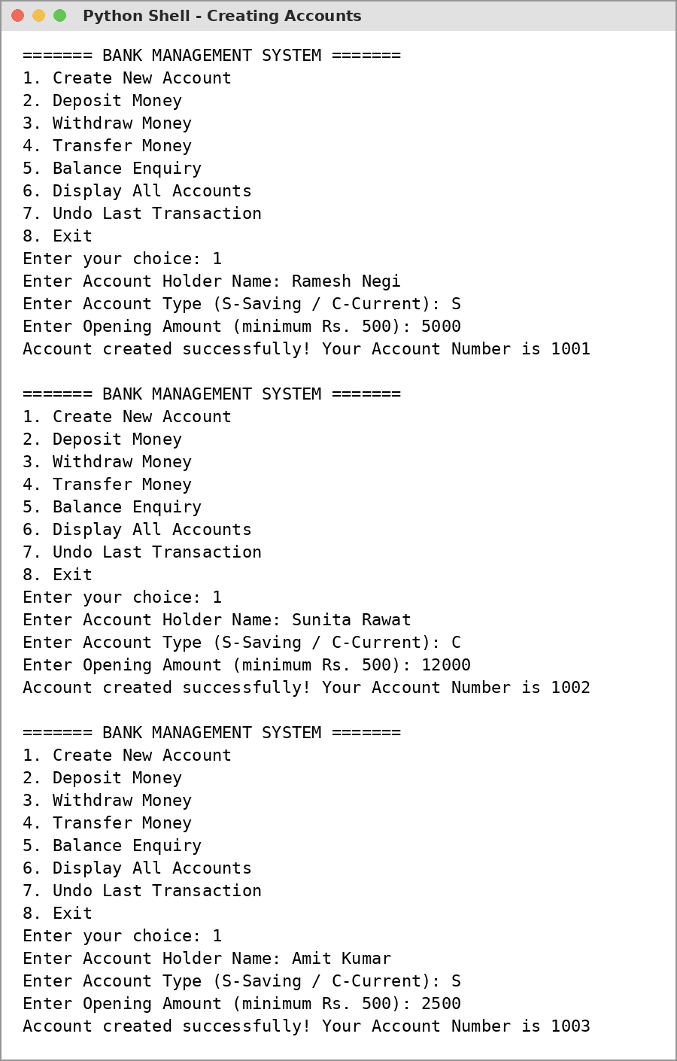

Output 2: Deposit and Withdraw
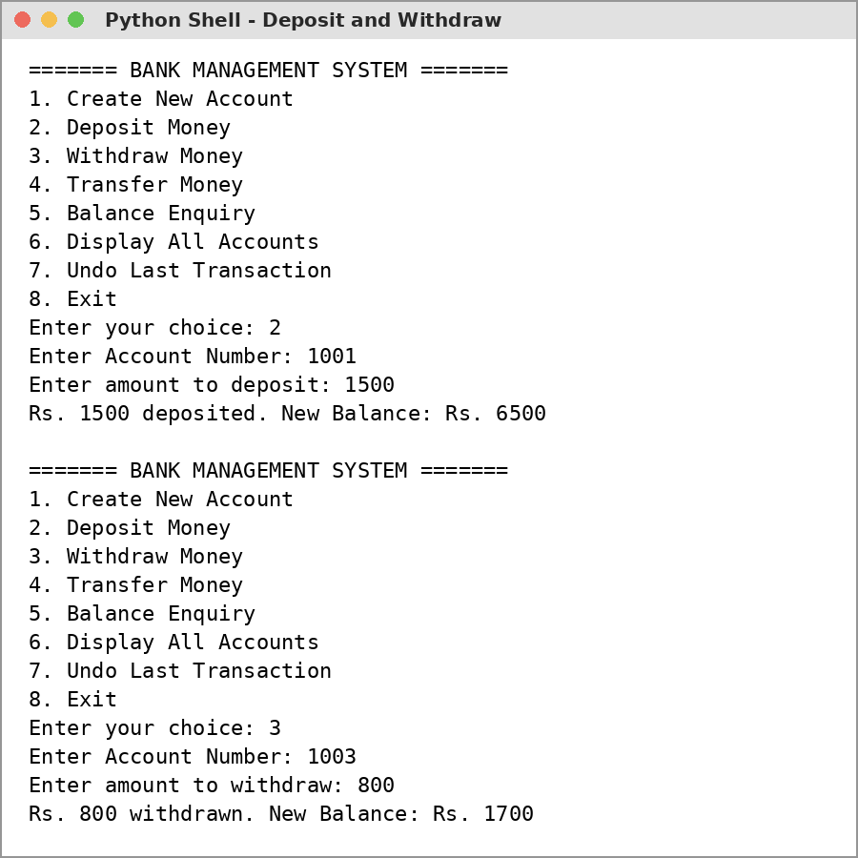

Output 3: Exception Handling
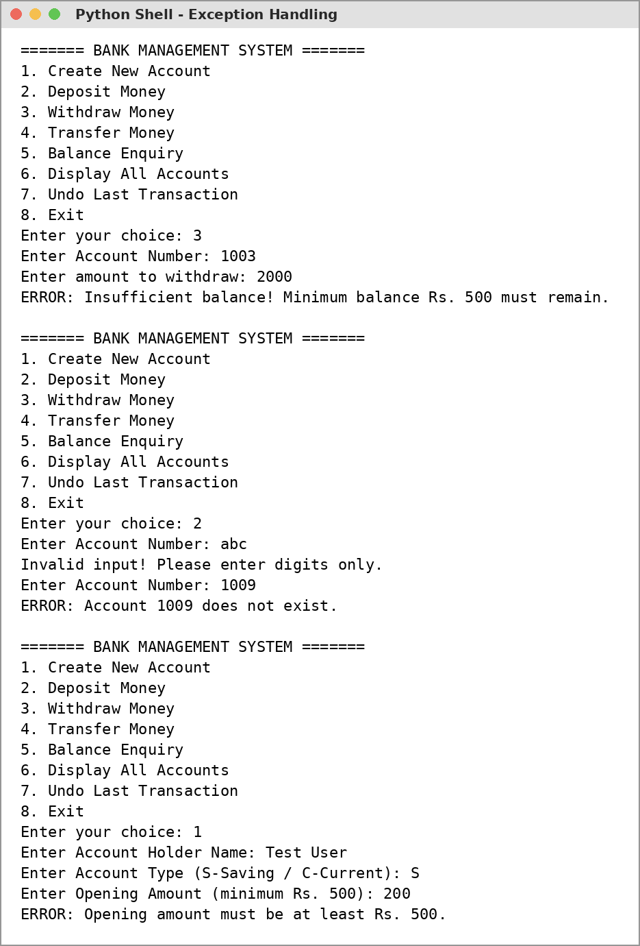

Output 4: Transfer and Balance Enquiry
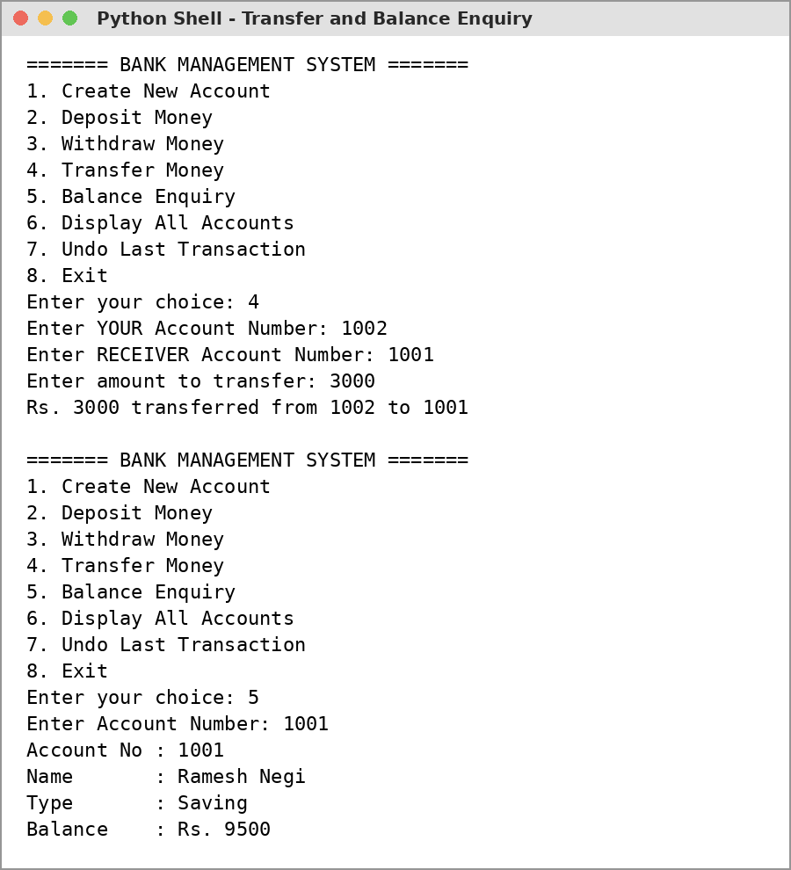

Output 5: Display All and Undo
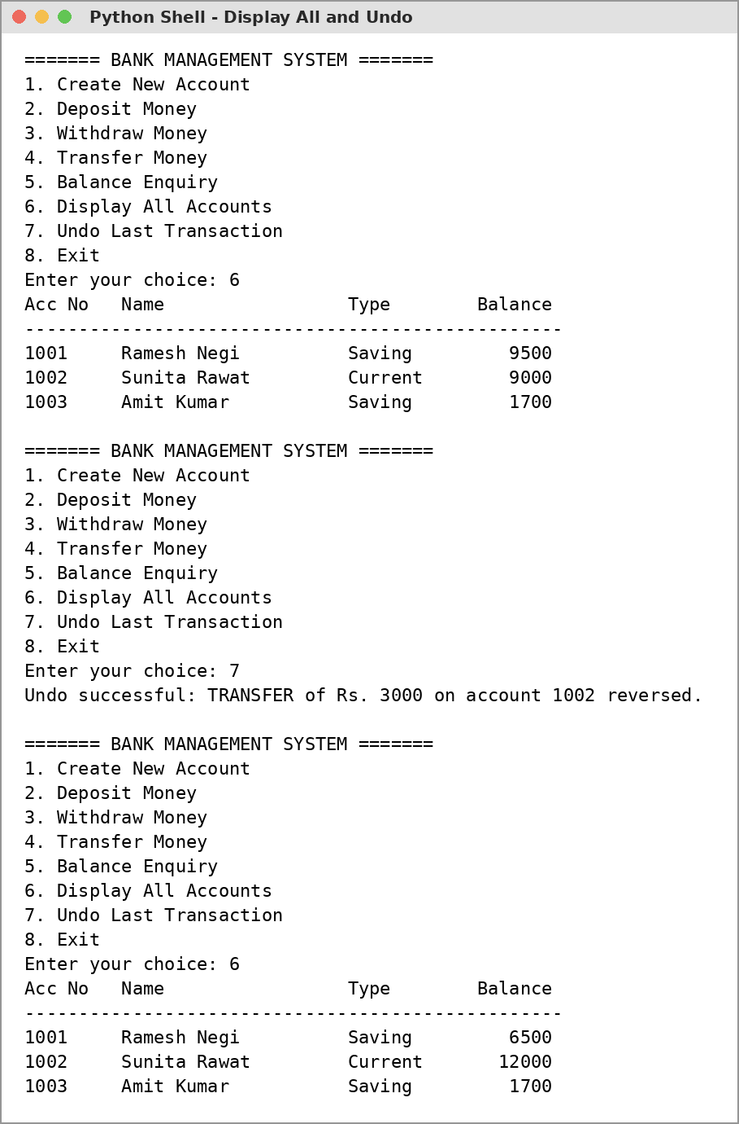

Output 6: Undo Stack Empty and Exit
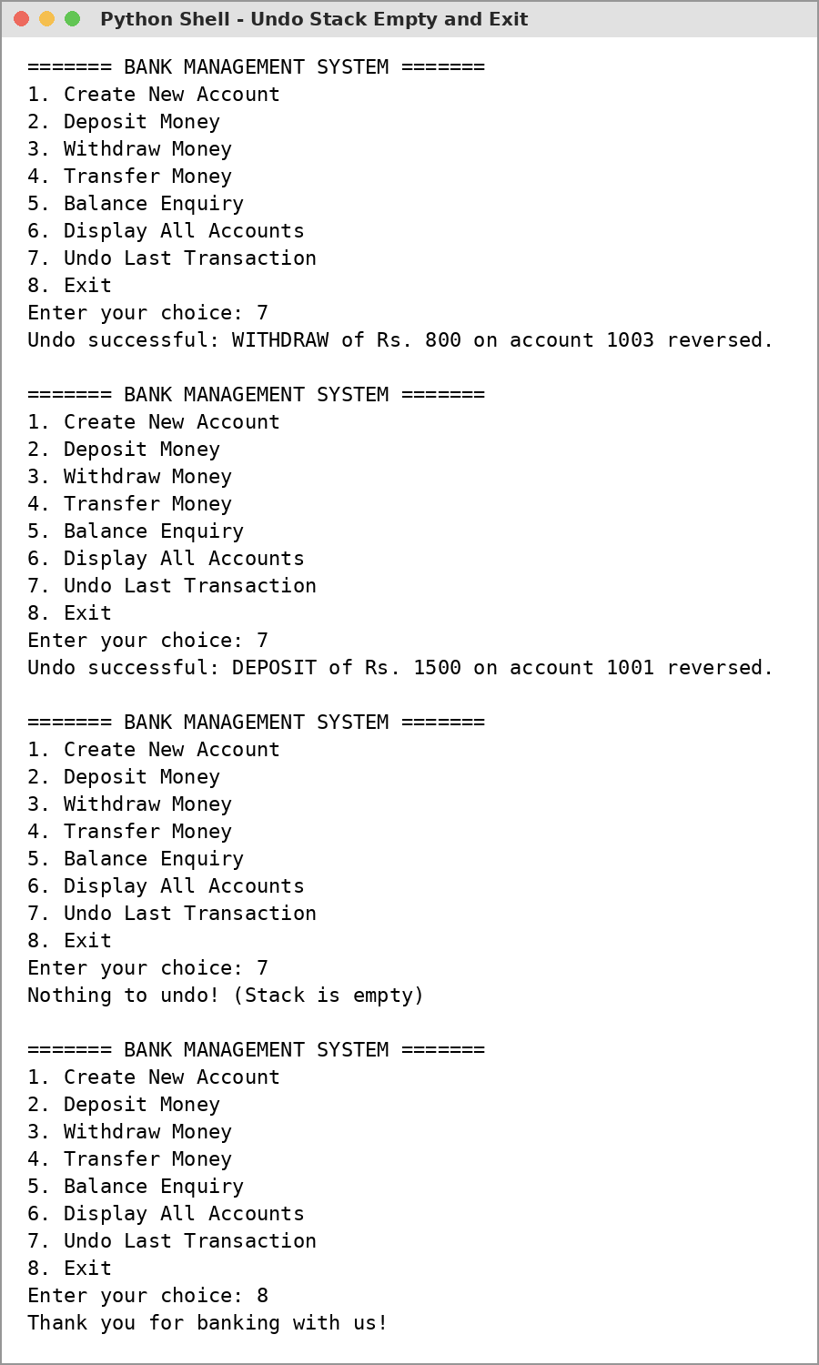

Technological Requirements: Hardware & Software
Software
- Python 3.x (IDLE)
- VS Code / any text editor
- Windows 10/11 or Linux
Hardware
- Laptop / PC with Intel Core i3 or above
- 4 GB RAM or more
- Keyboard and Mouse

References
- Computer Science with Python - Textbook for Class XII (Sumita Arora)
- NCERT Computer Science Textbook for Class XII, Chapters: Exception Handling, File Handling, Stack
- https://docs.python.org/3/tutorial/errors.html
- https://docs.python.org/3/library/pickle.html
- https://www.python.org/

